# bitcoin Trading Insights: A Comprehensive Financial Report

Introduction:  
Cryptocurrencies have revolutionized the financial landscape, and 'bitcoin' stands out as one of the most prominent digital assets in the market. This financial report aims to provide traders with valuable insights into the nature of 'bitcoin,' its benefits for trading, and a summary of its financial performance. Please note that the following report is for informational purposes only and does not constitute financial advice.  
  
1. What is 'Bitcoin':  
'Bitcoin' is a decentralized digital currency that operates on a peer-to-peer network known as the blockchain. Created in 2009 by an anonymous person or group of people using the pseudonym Satoshi Nakamoto, 'bitcoin' was designed to enable secure, borderless transactions without the need for intermediaries such as banks. It utilizes cryptographic techniques to ensure the integrity and security of transactions.  
  
2. Benefits of Trading with 'Bitcoin':  
Trading 'bitcoin' offers several advantages to traders:  
  
 a. High Liquidity: 'Bitcoin' is one of the most actively traded cryptocurrencies, providing ample liquidity for traders to enter and exit positions with ease.  
  
 b. Volatility: The cryptocurrency market, including 'bitcoin,' is known for its price volatility. This volatility presents opportunities for traders to profit from short-term price movements.  
  
 c. 24/7 Market: Unlike traditional financial markets, the 'bitcoin' market operates around the clock, enabling traders to take advantage of price fluctuations at any time.  
  
 d. Diversification: Including 'bitcoin' in a diversified investment portfolio can help reduce overall risk and potentially enhance returns.  
  
3. Financial Summary:  
In this section, we present key financial information about 'bitcoin':  
  
 - Total Circulating Supply: 29,089,811 USDT (as per 'bitcoin''s official reports)  
 - Market Capitalization: 357,408,227 USD (based on the market price at the time of the report)

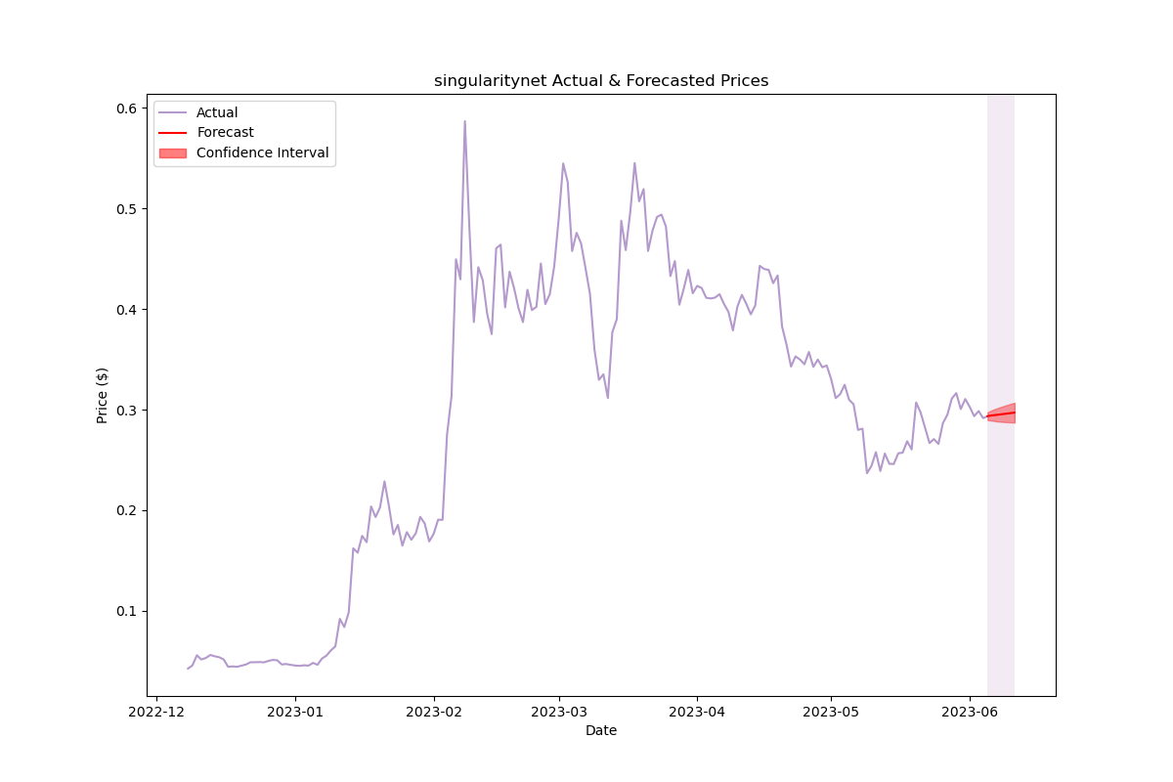

Explanation: Latest 6 months price and forecasted 7 days.

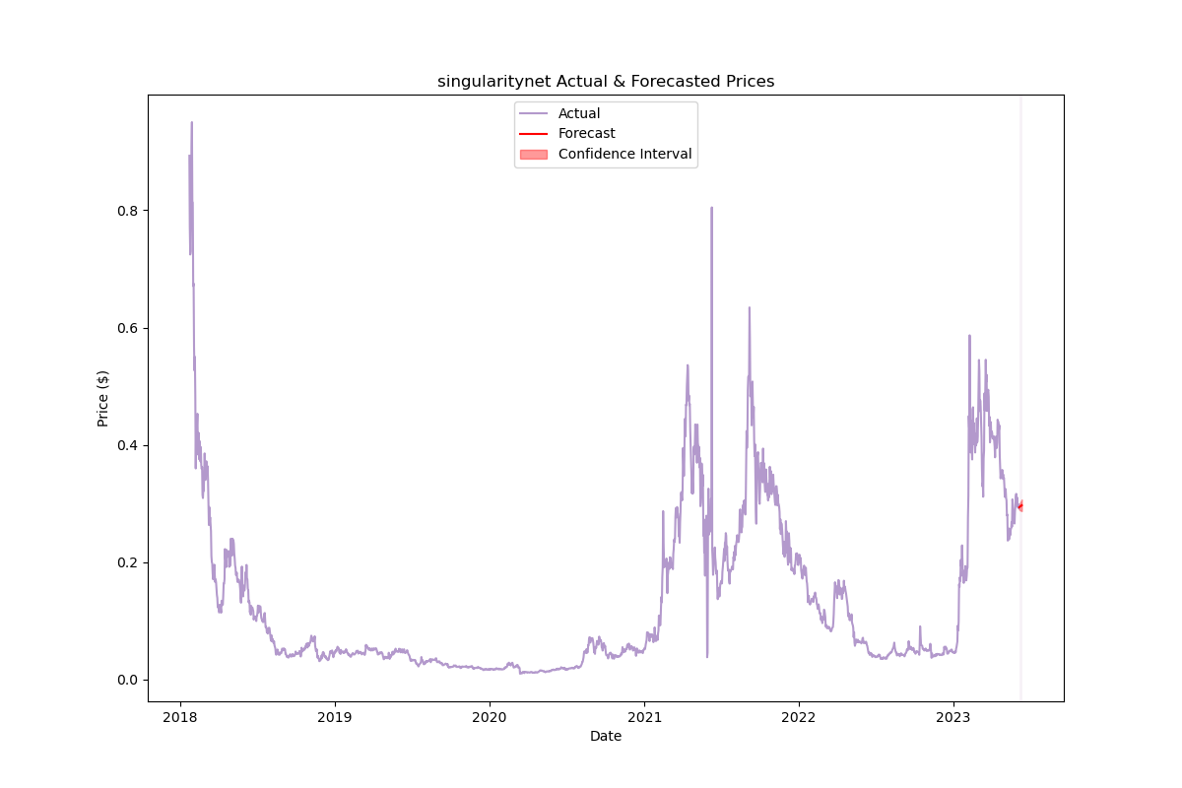

Explanation: Whole price and forecasted 7 days.

Please note that the following section is for informational purposes only and does not constitute financial advice. The content for this section will be provided separately, and you are responsible for conducting your own analysis and making informed trading decisions.  
  
It is important to remember that trading cryptocurrencies involves risks, and past performance is not indicative of future results. The information provided in this report is based on the current market conditions and available data, and it is crucial to seek professional advice and perform due diligence before engaging in any trading activities.